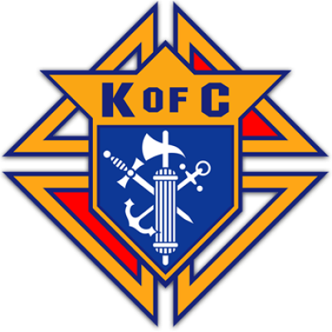 Knights of Columbus

Business Meeting Minutes

October 28, 2020

Call to Order
Wednesday, 10/28/20 at 7:30 PM

Warden’s Report on Membership
All present are current members

Prayer
Our Father prayer was recited

Pledge of Allegiance
Pledge was recited

Roll Call of Officers
Grand Knight David McNicoll P /
Chaplain Rev. Martino / E
Deputy Grand Knight John Davis P/
Chancellor Bill Fogarty P /
Financial Secretary Richard Harrison / E
Recorder Tim Hood P /
Treasurer Rick Monteleone P /
Advocate Lenny Danielwicz / E
Warden Aaron Gilstrap P /
Inside Guard Roger Lafond P /
Outside Guard Pat Kavanaugh P /
1 Year Trustee Gary Hixenbaugh P /
2 Year Trustee Douglas Klutzke P /
3 Year Trustee Paul Tanguay / E

Reading of Minutes from Previous Meeting
Minutes were read from the September meeting. Minutes were approved as read. Motion D Klutzke, Second J Davis. Approved by unanimous vote.

Meeting Minutes for October 28, 2020

- Motion to Accept September Meeting Minutes as read.
- Report of Admission Committee and Reading of Applications- no report
- Grand Knight Report - Richard Harrison has resigned as Financial Secretary. David nominates Aaron Gilstrap. Passed unanimously. New Warden must be found. Everyone present as the meeting already holds an office. There was discussion about if a quorum was present. Covid 19 has relaxed these rules. Decision was made to table the item for later. BOSTON BUTT - David has not gotten with Rusty Pig since they’ve been closed. The decision was made to postpone the sale until after the holidays. Target time will be the Super Bowl. NOVEMBER MEETING- motion was made by Doug to cancel the meeting. Second by Bill Fogarty. Motion passed unanimously. DECEMBER- should we have a Christmas Party? Keep the bonds and relationships of the council going? David was open to suggestions. We’ve only been having around 12 people. Should we have a party for that small group? How about a grill out at someone’s house? David and Tim will check about their homes. Motion was made to cancel the party for this year and the December meeting. Tim made a motion to wait to decide based on interest. John Davis seconded the motion. We will vote electronically later in November.
- Bills and Communications- Weird letter was received from the “Angel of the Lord”. The letter was read aloud by the recorder.
- Chaplain Report - NA
- Treasury Report - read by Rick Monteleone (see handout) Budget was passed.
- Financial Secretary Report - No Report
- Trustees Report - Fourth Degree meeting will be held at SBC for November. If anyone is interested in taking the 4th Degree, there will be a virtual meeting. Contact Doug.
- Chancellor Report - Bill Fogarty has gotten the name of our new Seminarian. Tony Visintainer (sp?) Going to school at the same place as Theodore. Should be in the class of 2022. He immediately responded to our letter. Bill read his letter to the attending members. Bill has already written him back telling him about our council and SBC. We will send him two qrtly checks to him now, and then $125 per qtr until ordination. Bill has written him another letter to accompany the check. Motion to approve amounts was made by Tim, seconded by Pat. Motion passed unanimously. RSVP- According to our records, $100 check from RSVP has not been received. Bill has inquired about it. Bill needs to find out how to request a new check. He has not been given a response to that question. It was suggested to keep calling them until we get an answer. PRO LIFE- Allen Bazemore heads up our committee. Our parish sign has been damaged. No one knows who did it. The banner was destroyed. He wants to replace it. Total will be $500. Bill suggested a four way split. Allen, Bill, Parish, and Kof C. $125 each. Bill has a copy of the invoice. (given to David) Discussion was made. Are we doing “Coats for Kids”? $500 for the box of coats. Doug made a motion to help Allen. Second by John. Motion passed unanimously.
- Unfinished Business - More Coats for Kids Discussion. Fundraising will play a key role in doing this. It is budgeted for $480 for the box of coats. CHRISTMAS CARDS need to be sold. There are plenty in stock. They will be placed in the sacristy. Sold at Masses.
- New Business- None
- Next Meeting is
  - Officers 1/21/21 at 7:00
  - Business 1/27/21 at 7:30
- Good of the Order - all brothers sick and distressed (see previous list)
  - Added to the list - Rachel Kavanaugh, Father Lamb, Hurricane Victims in the Gulf States, Alan Baker's wife.
- Closing Prayers - Our Father, Hail Mary, Glory Be
- Decade of the Rosary
- Meeting Adjourned - 8:30PM

