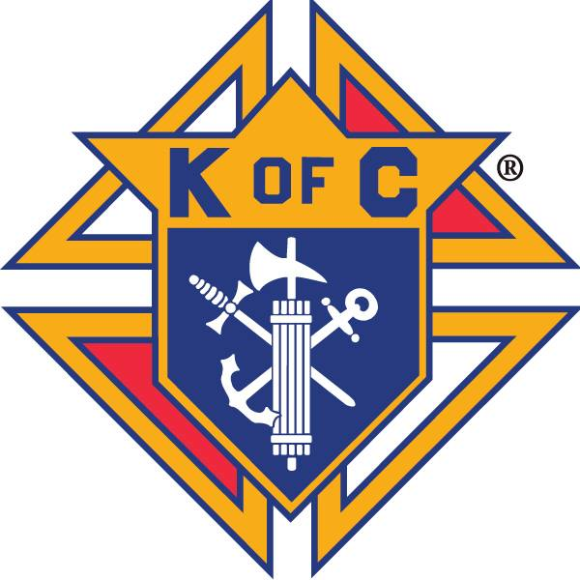
Knights of Columbus Council #14439
Business Meeting Minutes
July 25th, 2018

Call to Order
Wednesday July 25th, 2018 at 7:38 p.m.

Warden’s Report on Membership Card
All present are current members.

Prayer
Our Father prayer was recited.

Pledge of Allegiance
Pledge of Allegiance was recited.

Roll Call of Officers (circle)
Grand Knight Doug Klutzke Present
Chaplain Rev. Martino Nguyen Ba-Thong Excused
Deputy Grand Knight Gary Hixenbaugh Present
Chancellor Bill Fogarty Present
Financial Secretary Joe Colanero Present
Recorder Richard Harrison Present
Treasurer Rick Monteleone Present
Advocate Lenny Danielwicz Excused
Warden Aaron Gilstrap Present
Inside Guard David McNicoll Present
Outside Guard Roger Lafond Present
1 Year Trustee Paul Tanguay Excused
2 Year Trustee Chris Weber Excused
3 Year Trustee Joe Bahm Excused

Reading of Minutes of Previous Meeting
Minutes read and approved
Motion to approve minutes as read: Charlie Miller
Seconded: Roger Lafond
Motion Passed

Report of Admission Committee and Reading of Applications
No report

Grand Knight’s Report
Sign up for august 12th quarterly mass and installation of officers. Please bring your families out, and there will be a meal to follow.

Thank you to everyone who helped move the Matzdorf twins, and Loretta.

October 20th quarterly mass moved to November 3^{rd.} It was the same weekend as the chicken dinner and the golf tournament.

Chaplain’s Message
No report

Treasurer’s Report
Bank balance as of 05/31/2018 $4,598.23
Cleared checks -$199.31
Deposits +$60
Account Balance (06/29/2018) $4,458.92
Outstanding checks/Debits: $104.90
Account Balance (as of 07/25/2018) $4,348.92

Reading by Grand Knight of Receipts of Treasurer to Financial Secretary and Treasurer’s Voucher of Deposit
Since our June meeting, there have been 4 receipts submitted totaling $574 and 3 vouchers submitted totaling $338.24

Reading of Bills and Communications
Letter to Theodore Agba was read.
Card from Loretta Dahlweiner and the Matzdorf twins was read.

Financial Secretary’s Report of Receipts of Meeting
The $100 reimbursement from RSVP for our support of Theodore Agba has been received.
The $400 check for our donation to outreach has been received. Along with a plate for our plaque.
The Financial secretary has started the semiannual audit.
Preliminary budget was distributed. Will be emailed to all council members. Budget will be discussed and voted on next meeting.

Report of Auditors and Trustees
No report

Chancellor’s Report on Vocations

The quarterly check for Theodore Agba of $125.00 will be mailed tonight. This is his last year in the seminary. Next year we will be asking the state to pair us with a new seminarian.

Jase Whatley thanked the council for his sponsorship of vocations camp, and he expressed interest in going again next year.

Report of Service Program Committees
No report

Unfinished Business

- Congratulations to Gilstrap Family for June Family of the month
  - Nominations for July Family of the Month
Czachowski family nominated
Motion was make by Charlie Miller
Seconded by Gary Hixenbaugh
Motion passed

New Business
- Quarterly Mass Signup
- Officer Installation August 12th after 11:00 Mass, all Knights and their families are invited
- Tremendous thanks to all who helped move the Matzdorfs
- Joe and Monica Bahm Anniversary Mass July 28th 11 am. Please come in regalia, and give them a good showing from the Knights.
- Work day request in the rectory Aug. 17th.
- Golf Tournament Oct. 20th
  - Committee Members needed, contact Doug or Paul. Please hit up Businesses for sponsorships, and teams to play.
  - Grand Knight is working on website for the tournament. Players would be able to pay using PayPal. More discussion at next meeting.
  - August start up for committee meetings.
- Chicken Dinner Cooking Oct. 19th Please help if available.
- Christmas Card Ordering
Motion to buy 1 box of cards at $140 Made by Jake Peavey
Seconded Charlie miller
Motion Passed
- Knights Breakfast/ September 23rd. $5 per ticket. 12 years old and under free. All profits go to building fund.
- An additional day is needed for finishing moving the Matzdorf twins.
- 1st degree exemplification. If we hold one district will get people in for it. If you know anyone interested, have them contact an officer, or fill out a membership form.
- Church town hall meeting and building new church were discussed.
- 2017/18 Quarterly Masses – mark your calendar
August 12th 2018 at 11:00 am November 3rd 2018 at 5:00 pm
February 3rd 2019 at 8:00 am May 4th 2019 at 11:00 am
July 13th 2019 at 4:00 pm (Officer Installation)

Report of the Fourth Degree
No report

Good of the Order

Fr. Lamb Matzdorf twins Michael Barajas

Fr. Martino Vince Mackey Kavanaugh family

Fr Isadore Barbara & Ed Larosche Dick & Ida Rohrer

Lenny Danielwicz Barajas family Public servants

Gary Ogden Bernie/Karen Russo Bernie Weber

Bahm Family Ellis family Sandra Embly

Elise Kevin Klutzke Rose Danielwicz

Peggy Segar Loretta Delray Jill Newman

Lee Davis Vocations Sem. Theodore Agba & family

Joe Bahm Tim Fogarty Kathy Edenfield

Nancy Miller Jean Lafond Chris Weber

Tim Hood Paul Tanguay I & II Pedro Rodriguez and Family

Rita Visconti Harrison Family Berthalicia Perez

McNicoll Family Ken Copley’s Brother Paul Tanguay
All men and women in the U.S. Armed Forces Henry Tanguay
Debora Laugherty Fay Czachowski Fr. Martino’s parents

Closing Prayer
The Our Father, Hail Mary, and Glory Be was recited
The 3rd Decade of the Glorious Mysteries of the Rosary was recited

50/50 Drawing
50/50 Drawing was held and $16 was won by Alan Baker. $16 donated to Pennies for Heaven

Next Meeting
The next Officer’s Meeting will be August 16th, 2018
The next Business Meeting will be August 22nd, 2018

Adjournment
The meeting was adjourned at 8:30 p.m.

Submitted by Recorder, Richard Harrison, July 30th, 2018


