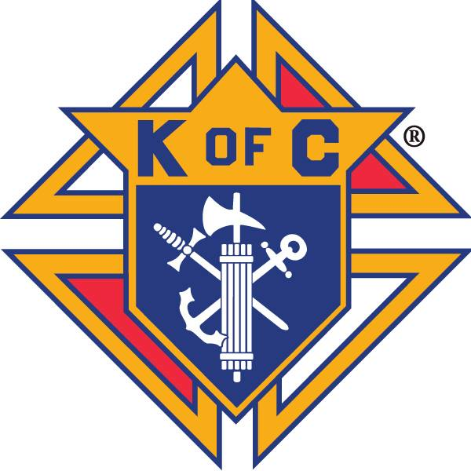
Knights of Columbus Council #14439
Business Meeting Minutes
Wednesday October 24th, 2018

Call to Order
Wednesday October 24th, 2018 at 7:35 p.m.

Warden’s Report on Membership Card
All present are current members.

Prayer
Our Father prayer was recited.

Pledge of Allegiance
Pledge of Allegiance was recited.

Roll Call of Officers (circle)
Grand Knight Doug Klutzke Present
Chaplain Rev. Martino Nguyen Ba-Thong Excused
Deputy Grand Knight Gary Hixenbaugh Present
Chancellor Bill Fogarty Present
Financial Secretary Joe Colanero Present
Recorder Richard Harrison Present
Treasurer Rick Monteleone Present
Advocate Lenny Danielwicz Present
Warden Aaron Gilstrap Present
Inside Guard David McNicoll Present
Outside Guard Roger Lafond Present
1 Year Trustee Paul Tanguay Present
2 Year Trustee Chris Weber Excused
3 Year Trustee Joe Bahm Excused

Reading of Minutes of Previous Meeting
Motion to approve minutes made by Paul Tanguay
Seconded Lenny Danielwicz
Motion approved

Report of Admission Committee and Reading of Applications
No report

Grand Knight’s Report
- Thank you to Paul for picking up Pizza
- Coats for kids: we will purchase from Knights of Columbus Supreme
- Knights mass sign-up sheet coming around. November 3rd 5pm mass.
- All soul’s day service in Springfield veterans park November 11th between mass’s. Father would like 4th degree to dress out. Show time
- Oyster roast has been moved to November 10th. Please help set up tables after 5pm mass.
- Huge thanks to Gary/Paul/Bill/Lenny/Rick who helped split wood for Chicken Dinners
  - Thanks to Tom Liebl for allowing us to borrow his splitter

Chaplain’s Message
No report

Treasurer’s Report
Bank balance as of 08/31/2018 $3542.10
Deposits +684.00
Account balance (09/28/2018) $4,226.10
Total outstanding checks/debits $710.00
Account balance (as of 10/24/2018) $3,516,00

Reading by Grand Knight of Receipts of Treasurer to Financial Secretary and Treasurer’s Voucher of Deposit
Since our September 26th meeting, there have been 3 receipts submitted totaling $231 and 4 vouchers submitted totaling $302.86

Reading of Bills and Communications
Card was read from Theodore Agba
Letter was read to Theodore Agba

Financial Secretary’s Report of Receipts of Meeting
Father Lamb donated a $100 check to our breakfast, bringing the total donated to the building fund to $441.11.

Report of Auditors and Trustees
No report

Chancellor’s Report on Vocations
- Quarterly check is being sent to Theodore Agba
- Thanks for thoughts and prayers for our diaconate applicants
- No update on our diaconate candidates yet. Something to consider; sponsoring them at $25 a month to help with gas money for the applicants.
- Alter server training: November 3rd 10-12am and November 8th 6-8pm
- Keep Christ in Christmas poster contest will be announced after Christmas break. They will have a full two weeks to work on them. Checks have already been approved as part of the budget.

Report of Service Program Committees
Respect for life gathering took place. Several Knights participated; 20-25 people total took part in the event.

Unfinished Business
- Dinner – Pizza
- Congratulations to Harrison Family for October Family of the month
  - Nominations for November Family of the Month
Paul Tanguay Nominated the Monteleone family
Seconded Joe Colanero
Motion passed
- Time to start selling Christmas Cards after masses. Thank you to Joe Colanero and Rich Harrison for selling after the late mass on Sundays. More than half have already been sold.
- Knights Mass signup
- Oyster Roast moved to November 10th
  - Set up tables after 5pm mass
- Coats for Kids options

New Business

- Family care center charity dinner at Mighty eighth. Two seats left, Contact Paul for more info.
- Council 631 letter (Ultrasound Initiative) August they gained approval for an ultrasound initiative. The goal is to raise half of the funds needed to purchase an ultrasound machine. $18,000 is our half.
Assembly of the 4th degree donated $1,500
92% of mothers who see the baby via an ultrasound keep the babies.
Motion to donate $150 made by Paul Tanguay
Seconded Pat Kavanaugh
Motion passed
- Per parish council: any fundraising events held at church must go through parish council prior to starting fundraiser.
- Christmas Party December 15th after 5pm mass
  - Will take place of December meeting
  - Huge thanks to Rocio Harrison for taking lead, look for more info to come
- 2017/18 Quarterly Masses – mark your calendar
November 3rd 2018 at 5:00 pm February 3rd 2019 at 8:30 am
May 5th 2019 at 11:00 am
July 13th 2019 at 5:00 pm (Officer Installation)

Local Insurance Agent Contact: Billy Schmidt Phone: 912-247-1544
Email: billy.schmidt@kofc.org

Report of the Fourth Degree
- Exemplification Nov. 10th in Marietta Ga
- All soul’s day Nov.11th between the masses show time 9:45
- Nov. 12th veteran’s day parade if you want to dress out please contact Paul.
- 4th degree assembly is now sponsoring Theodore Agba as a seminarian. They are sending a $500 check for a full year of support.

Good of the Order
Fr. Lamb Fr. Martino Rose Danielwicz
Paul Tanguay Sr. Miller Family Bahm Family
Our Parish Loretta Dahlwiener Caravan Immigrants
Doran Family Clergy Davis Family
Barbra & Ed Laroch Karen Russo Gleaton Family
Pat& Rachel Kavanaugh Everyone affected by Hurricane Michael
All men and women in the U.S. Armed Forces The Church as a whole

Closing Prayer
St Michael prayer was recited
The Our Father, Hail Mary, and Glory Be was recited
The 1st Decade of the Joyful Mysteries of the Rosary was recited

50/50 Drawing
50/50 Drawing was held and $15 was won by Jake Peavey. $15 donated to Pennies for Heaven

Next Meeting
Next Officer’s Meeting – TBD due to Thanksgiving
Next Business Meeting –Thursday, November 29th

Adjournment
The meeting was adjourned at 8:29 p.m.

Submitted by Recorder, Richard Harrison, October 26, 2018.


